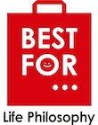

“BEST FOR” THE NEW PHILOSOPHY STORES
"BEST FOR" is a company whose idea originated in Japan and is developing with the Franchise method. Its philosophy is retail stores that provide products for everyday use, high-design concepts with a private label packaging.
At our stores we attract customers through product quality, eccentricity and prices that are constantly renewed to achieve repeated traffic.
For this reason, we created a modern, fresh and cheerful store environment.
In our stores we want every customer to understand that we respect the value of his money, giving them the sense of "Value for money".
The locations we choose for our shops are large shopping centers and lively streets.
It is a brand that is close to the life and the needs of customers, combining price, quality, innovation and Design.

OBJECTIVES
At the moment, the company has developed stores in Greece, Serbia Romania and Cyprus.
At the same time, we are evaluating the development of stores in Italy, Germany and Poland.

Products

Our products are REALLY addressed to all age and income groups. This is also clearly apparent from the individual titles of our brand name.
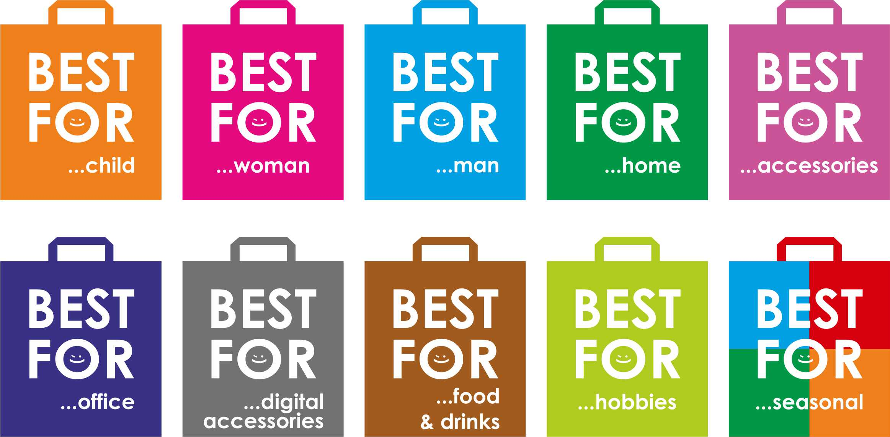
Best For Woman – Best For Child – Best For Man – Best For Home – Best For Accessories – Best For Office – Best For Digital Accessories – Best For Food & Drinks – Best Hobbies – Best For Seasonal.
All our products are branded as "BEST FOR" on the packaging.

Target market strategy segment
We focus on the price, but also on the consumer who is looking not only for price but also for quality. A complete harmony of these two features is the philosophy of our company
Our products prices range from 1 to 60 euros. The goal of this pricing policy is to encourage the availability of customer purchases.

Competition and purchasing standards
Consumers require quality service, fair pricing, and a nice store environment that will host them for their purchases.
The competition is currently fairly high but no one yet offers the package and the product range of our business. In this area, we dare to say that we are a leader in Europe.
Using the design philosophy of a "simple, natural and high-quality product" we have almost accomplished every customer who visits the store not to leave without having purchased at least one product.
This is our Philosophy

